**Project Report::Online Exam Management System—Sql Project Documentation**

**Examjfkejjfhjhf Management System**

**Submitted By: Jajam Prasanna**

**Roll No:22KQ1A5412**

**Department:AIDS-A**

**College:Pace Institute Of Technology&Science**

**Introduction**

The Online Examination System is an SQL-based database project that enables conducting and managing online tests for students. This system allows administrators to create exams and questions, while students can register, take exams, and view their results. All records are stored and managed in a relational database using SQL operations and functions.

**Objective**

The objective of this project is to design a relational database that:

* Stores student details
* Manages exams and associated questions
* Records and evaluates results
* Automatically updates student exam status based on performance

**Modules**

**1. Student Management:**

This module allows the registration and management of student information such as name, email, and password.

**2. Exam Management:**

This module allows administrators to create exams with a specific name, duration, and total marks.

**3. Question Bank Management:**

This module stores all questions and multiple-choice options for each exam. It also stores the correct option to help in auto-evaluation.

**4. Result Management:**

This module records student scores and automatically sets pass/fail status using a trigger.

**ER Diagram Explanation**

*The ER diagram represents the relationship between the main entities of the Online Examination System.

* The **Student** entity contains personal details of users who take the exams.

* Each student can have multiple examination results, which is why there is a one‑to‑many relationship between **Student** and **ExamResult**.

* The **Exam** entity stores information about each test, and it is also linked to the **Question** entity in a one‑to‑many relationship because one exam contains multiple questions.

*The **ExamResult** table connects the **Student** and **Exam** entities and stores the score, date, and status of each exam attempt. This structure allows the system to manage students, schedule exams, store questions, and track results in a normalized way.

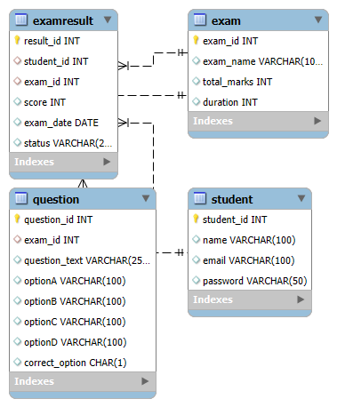

SQL Code

→CREATE DATABASE / CREATE TABLE

CREATE DATABASE OnlineExamDB;

status VARCHAR(20),

FOREIGN KEY(student_id) REFERENCES Student(student_id),

FOREIGN KEY(exam_id) REFERENCES Exam(exam_id)

);

→INSERT INTO

INSERT INTO Student(name,email,password) VALUES

('Priya','priya@gmail.com','12345'),

('Amit','amit@gmail.com','12345');

INSERT INTO Exam(exam_name,total_marks,duration) VALUES

('SQL Basic Test',50,30),

('Python Basic Test',50,30);

INSERT INTO Question(exam_id,question_text,optionA,optionB,optionC,optionD,correct_option) VALUES

(1,'SQL keyword to retrieve data?','SELECT','CREATE','INSERT','DELETE','A'),

(1,'Which SQL keyword is used to remove table?','DROP','ALTER','UPDATE','TRUNCATE','A'),

(2,'Which keyword defines a function in Python?','for','if','def','func','C');

→UPDATE

UPDATE Question SET optionD = 'TRUNCATE' WHERE question_id = 2;

→DELETE

DELETE FROM Student WHERE student_id = 2;

→WHERE / LIKE

SELECT * FROM Question WHERE question_text LIKE '%SQL%';

→GROUP BY + Aggregate functions

SELECT exam_id, COUNT(result_id) AS total_attempts, AVG(score) AS avg_score

FROM ExamResult

GROUP BY exam_id;

SELECT name FROM Student

WHERE student_id IN (

SELECT student_id FROM ExamResult WHERE status='Passed'

);

→Stored Procedure

DELIMITER //

CREATE PROCEDURE AddStudent(

IN sname VARCHAR(100),

IN semail VARCHAR(100),

IN spass VARCHAR(50)

)

BEGIN

INSERT INTO Student(name,email,password)

VALUES (sname,semail,spass);

END //

DELIMITER ;

→Trigger

DELIMITER //

CREATE TRIGGER set_status_after_insert

BEFORE INSERT ON ExamResult

FOR EACH ROW

BEGIN

IF NEW.score >= 25 THEN

SET NEW.status = 'Passed';

ELSE

SET NEW.status = 'Failed';

END IF;

END //

DELIMITER ;

INSERT INTO ExamResult(student_id,exam_id,score,exam_date)

VALUES(1,1,38,CURDATE());

**Conclusion**

*This project demonstrates how an Online Examination System can be implemented using SQL.

* It manages students, exams, questions, and results in a structured way.

* The use of procedures and triggers helps in automating routine tasks like student registration and result status updates.

*The design can be easily extended further to support multiple subjects and detailed analytics.